www.recapturit.com
THE Resource for Recaptured Building Materials.

Sticker Standard
An Inventory Management option from ReCapturit.com
Designed for Sellers who don’t have a Point of Sale system to keep track of their inventory, but available to anyone selling products on ReCapturit.com, our inventory stickers allow you to differentiate the products you’re selling on online from the ones that are only available in your local store.
These stickers can be printed easily in your home or office, using the PDF files we’ve provided, and 2x4” REPOSITIONABLE address labels. (Avery #58163 or similar.)
Best Practice for Sticker Placement:
We imagine you’ve already got this down, pricing regular inventory in your store, but just in case we remind you to avoid places where removing the sticker might damage the patina or remove paint.

FOR SALE SOLD
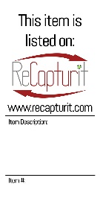
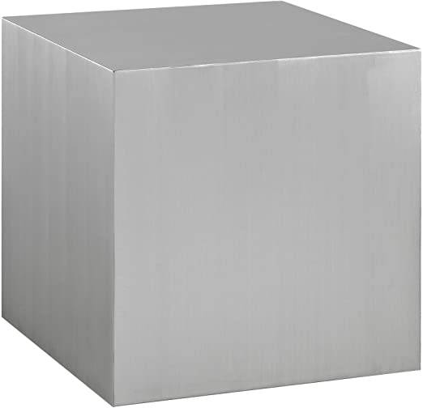
Perks of using ReCapturit Inventory stickers:
The ReCapturit inventory stickers allow you to advertise your online Seller Store, passively. Customers walking by will see the sticker, remember the name, and visit ReCapturit.com later.
The stickers also include a space to write the item’s description; to help keep smaller price only stickers from walking themselves over to higher priced items.
Happy selling.
www.recapturit.com

